Concordia University

SOEN 6441- Advanced Programming Practices

Project Report

Build 2

Game Development- Risk Game based on Conquest

Team 23

Syed Maqsood

Prashanthi Ramesh

Sardar Mutesham Ali Mohammed

Manasa Murali

Suthakhar Ponnambalam

Architecture Diagram:

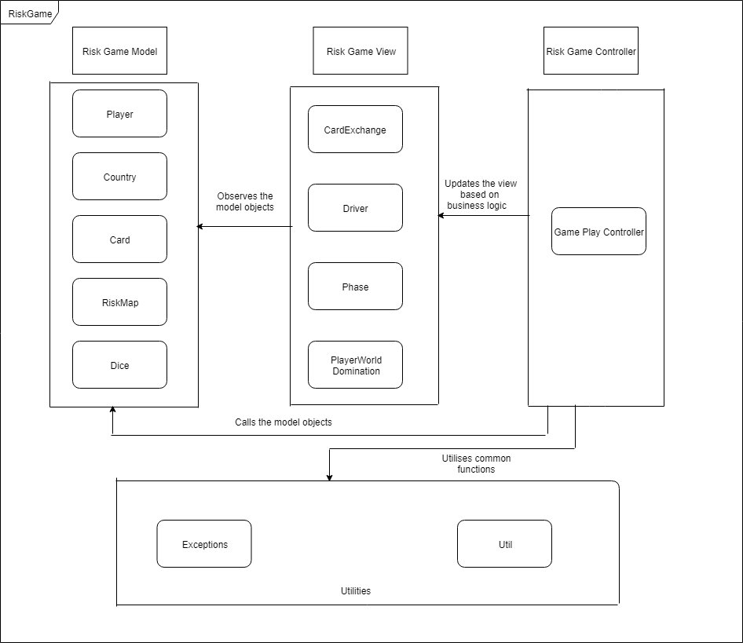

*Fig*: Architecture Diagram for Risk Game

In Build 2, we have the GamePlay as our controller that interacts with the model that makes necessary changes to the view when queried. The model component contains Player, Country, Card, RiskMap and Dice. Player class contains data about players such as name, the number of armies, the number of countries owned, the number of cards owned by that player. Country class has data about who owns the country and the number of armies placed in that country. View contains classes where the update takes place once there is a change in the model class. We also have the main class as Driver class which acts a like a request handler for our build.